M9 Problem 1

Initial ERD

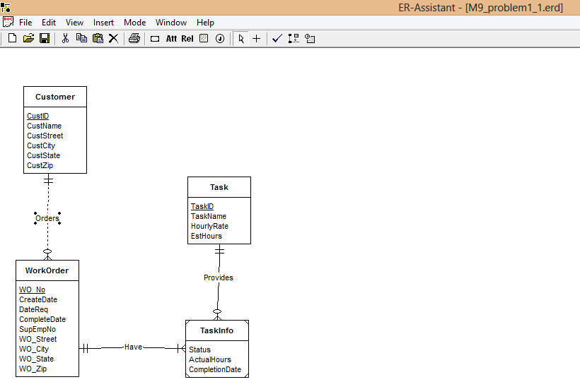

Design Analysis Decisions –

Entity and Attribute Identification – As given in problem specification entity types are clearly Customer, WorkOrder, Task, TaskInfo. TaskInfo entity is a weak entity.Attributes are directly given.

Primary key Identification – CustID, WO_No, TaskID are primary keys for Customer, WorkOrder, Task Entity types respectively.

Connect Entity Types –

From given problem statements –

1 Customer and WorkOrder should have one mandatory and many optional cardinality respectively.

2 Task and TaskInfo should have one mandatory and many optional cardinality respectively.

3 TaskInfo should be weak entity as primary key is not there in it’s attributes.

4 And WorkOrder and TaskInfo also have one mandatory and many optional cardinality.

5 move EstHrs to TaskInfo.

Revised ERD –

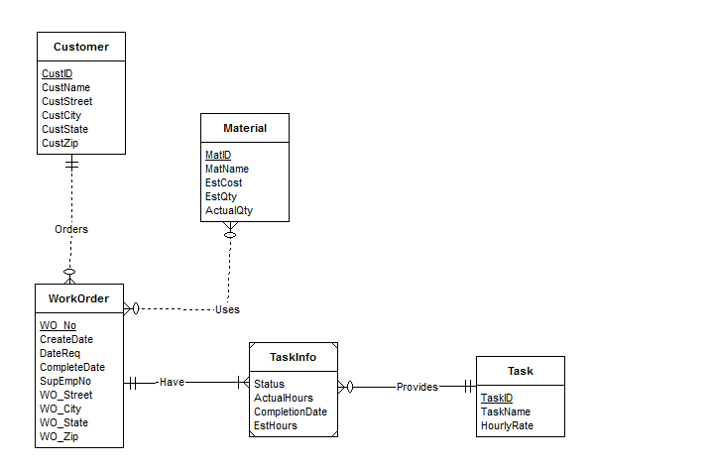

Design Analysis decision –

1 New entity type ‘Material’ is introduced and it’s attributes are also given in problem statement.

2 WorkOrder and Material should have M-N cardinality.